Sensitivity Analysis on NPV – Varun Beverages Perspective

Team Members (Group 3):
- Tejas Gupta
- Lakshmi Kumari
- Piyush Prashant Wagh
- Ashutosh Singh
- Sakshi Kalledevar

Case Context
Varun Beverages (VBL), one of PepsiCo’s largest global bottlers, evaluates capacity expansion and new bottling lines with long asset lives and volume-driven economics.
Management must assess how key drivers—price, quantity, capex, COGS, OPEX, Tax rate, DSO, DIO, DPO, WACC(i.e. discount rate)—affect NPV.
Sensitivity analysis isolates each driver’s impact on free cash flow and valuation to guide pricing, procurement, and financing decisions.

Financial Setup
· Planning horizon: 11 years.
· Currency: ₹ Crore; unit price in ₹; quantity in Crore units.
· Discount rate: WACC derived from the industry standard.

Sensitivity Design and Interpretation
Vary one input (Price, Quantity, Capex, COGS, OPEX, Tax rate, DSO, DIO, DPO, WACC(i.e. discount rate)) while holding others constant (Ceteris Paribus).

Glossary of Terms and Calculations

Price per Unit (₹)
· Calculation: Assumption per unit in ₹; can grow by an annual percentage.
· Description: Realised selling price per beverage unit/net price after trade schemes; a primary NPV driver due to operating leverage.
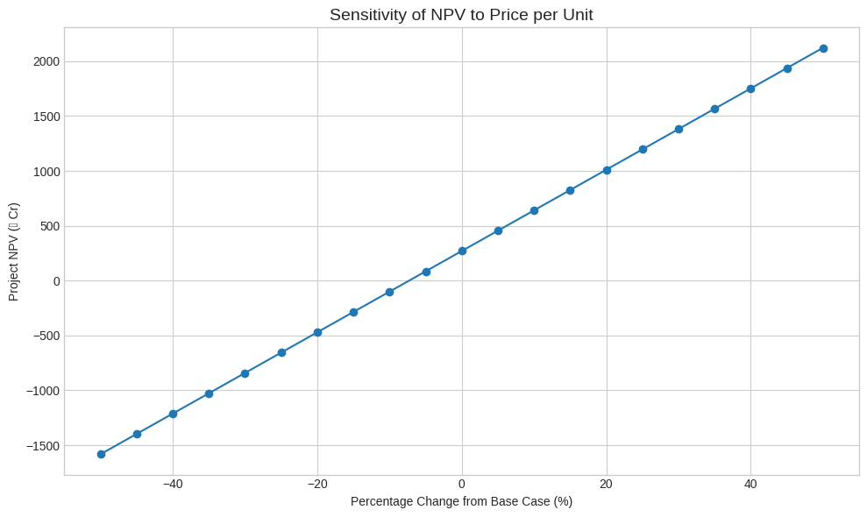

Sales Volume / Quantity Sold (# in Crore)
· Calculation: Assumed units sold per year; includes ramp-up curves and capacity constraints.
· Description: Demand and distribution execution; interacts with price to determine revenue scale.
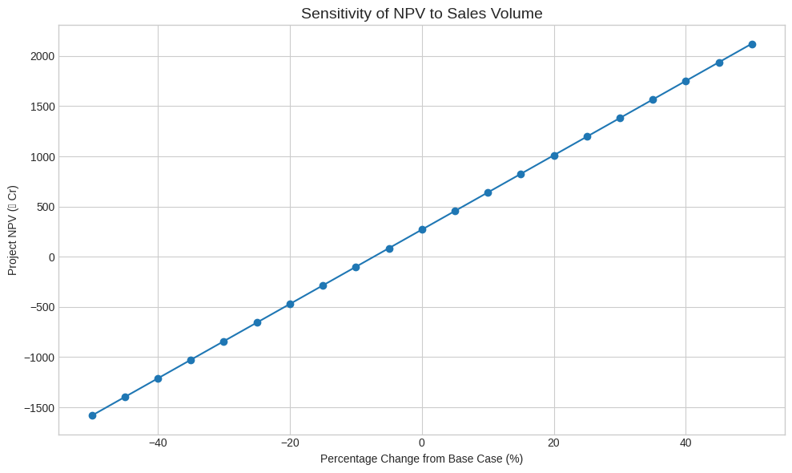

Revenue = Price × Quantity
· Calculation: Revenue (₹) = Price per Unit × Units Sold; Revenue (₹ Cr) = Revenue (₹) ÷ 1 Crore.
· Description: Top line of the model; base for margins, working capital, and depreciation allocation methods.

Revenue (₹ Cr)
· Calculation: See above (expressed in ₹ Crore).
· Description: Used to drive DSO-based AR and revenue-linked metrics.

Production Variable Cost (₹ Cr)
· Calculation: Typically % of revenue or unit cost × quantity.
· Description: Direct, volume-linked costs (ingredients, packaging, utilities, per-case logistics).

Production Fixed Cost (₹ Cr)
· Calculation: Base fixed costs with an annual growth rate; can increase with expansions.
· Description: Factory overheads not tied to monthly volume (plant supervision, rent, maintenance).

COGS = Variable Cost + Fixed Cost
· Calculation: Total of variable and fixed production costs.
· Description: Captures direct manufacturing economics to derive Gross Profit.

Cost of Goods Sold {COGS} (₹ Cr)
· Calculation: As above.
· Description: Used as the driver for inventory and payables when DIO/DPO are defined on COGS.
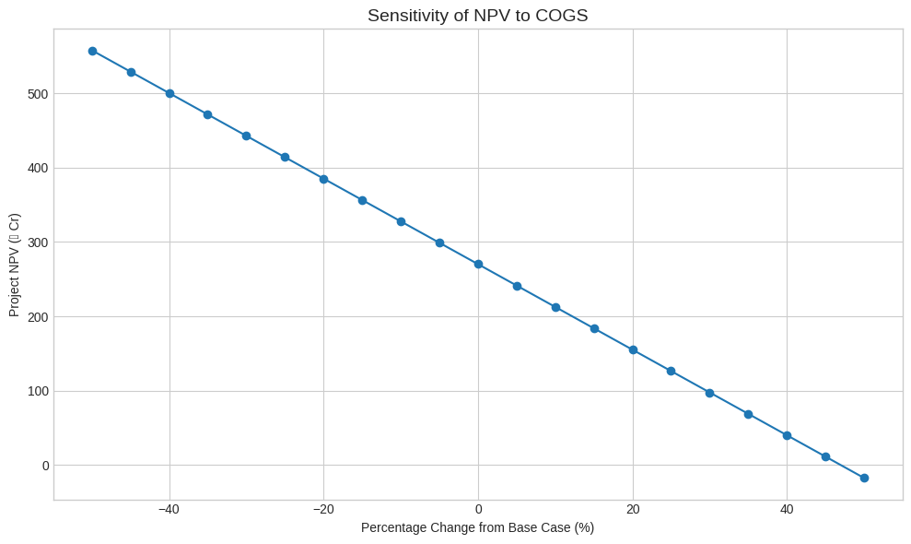

DSO
· Calculation: DSO=Total Credit Sales / Accounts Receivable​×Number of Days
· Description: Measures the average days it takes for a company to collect payment after a sale.

DIO
· Calculation: DIO=Cost of Goods Sold (COGS)Average Inventory​×Number of Days
· Description: Measures the average days a company holds inventory before selling it.

Operating Expenses {OPEX} (₹ Cr)
· Calculation: Indirect overheads (admin, marketing, distribution).
· Description: Below gross profit; impacts EBITDA directly.
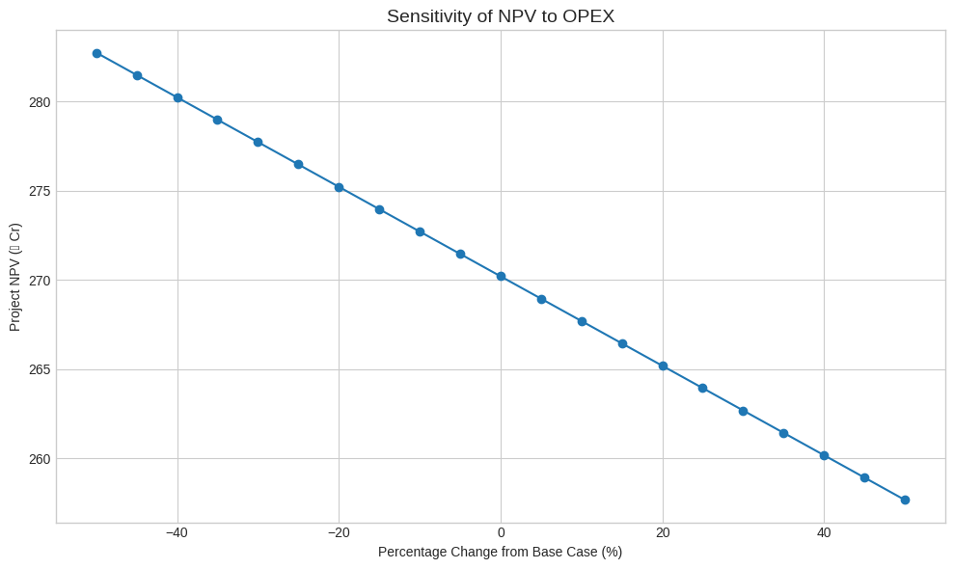

EBITDA = Revenue − COGS − OPEX
· Calculation: EBITDA (₹ Cr) = Revenue − COGS − OPEX.
· Description: Cash-like operating profit before non-cash charges; central for margin and leverage analysis.

Depreciation & Amortization (₹ Cr)
· Calculation: Straight-line or schedule-based on historical and planned capex.
· Description: Non-cash expense reflecting asset consumption.

EBIT = EBITDA − D&A
· Calculation: EBIT (₹ Cr) = EBITDA − Depreciation & Amortization.
· Description: Operating profit post non-cash charges; input to taxes.

Tax Rate (%)
· Calculation: Statutory or effective tax assumption.
· Description: Applied to EBIT to compute NOPAT.
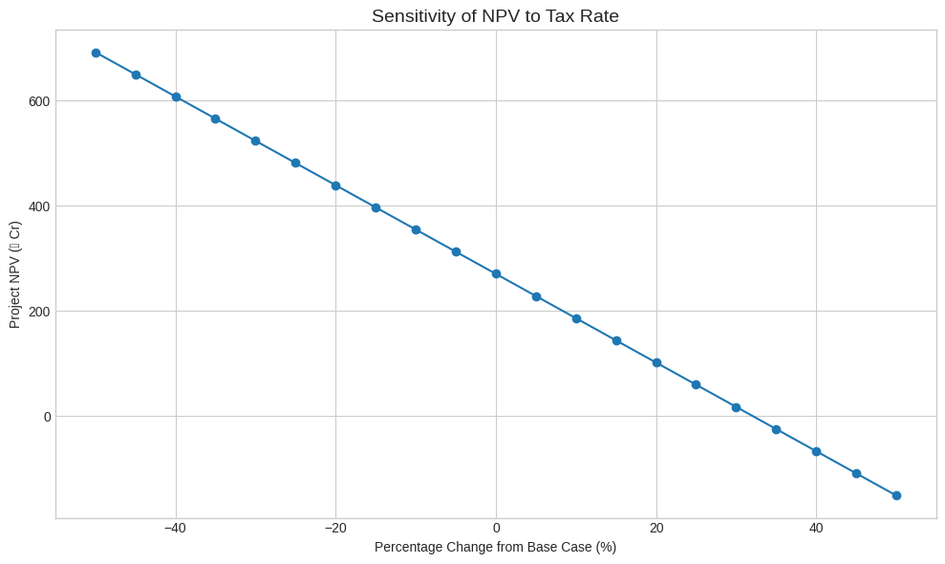

NOPAT = EBIT × (1 − Tax)
· Calculation: NOPAT (₹ Cr) = EBIT × (1 − Tax Rate).
· Description: After-tax operating profit independent of capital structure.

Operating CF = NOPAT + D&A
· Calculation: Operating Cash Flow (₹ Cr) = NOPAT + Depreciation & Amortization.
· Description: Adds back non-cash charges to derive cash generated before working capital and capex.

Receivable Days {DSO} (No. of Days)
· Calculation: Accounts Receivable = Revenue × DSO / 365.
· Description: Credit terms and collections efficiency; higher DSO ties up cash.
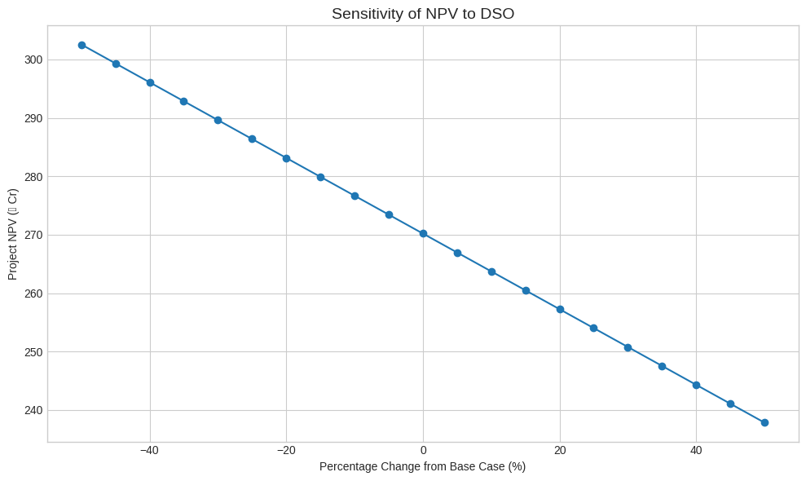

Inventory Days {DIO} (No. of Days)
· Calculation: Inventory = COGS × DIO / 365.
· Description: Stockholding efficiency; higher DIO increases inventory.
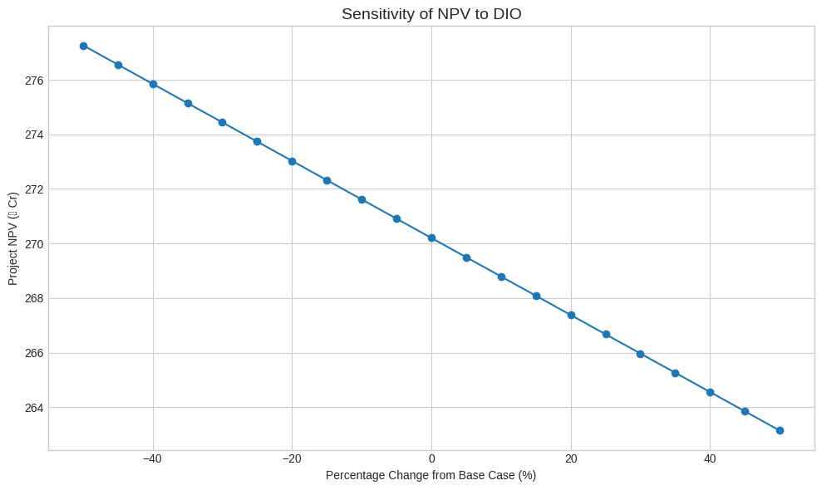

Payable Days {DPO} (No. of Days)
· Calculation: Accounts Payable = COGS × DPO / 365.
· Description: Supplier credit; higher DPO provides cash.
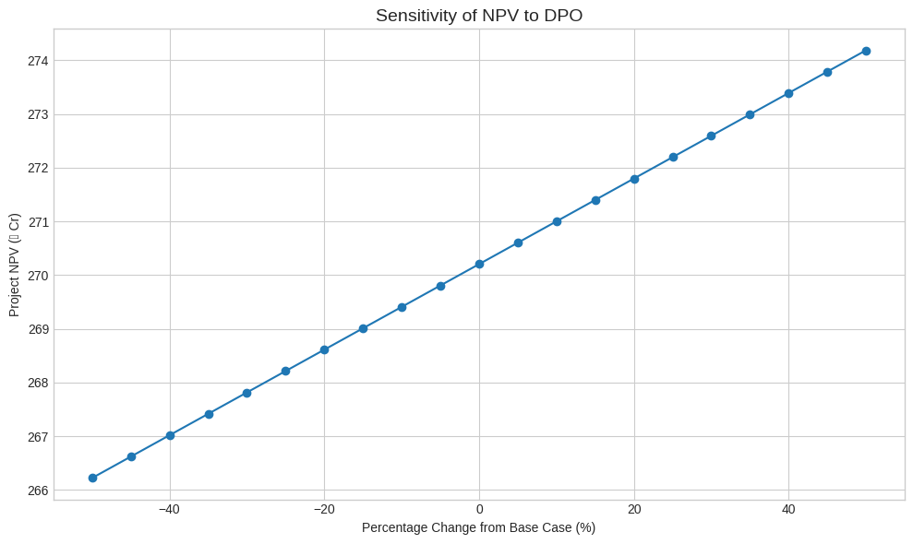

Net Working Capital (NWC)
· Calculation: NWC (₹ Cr) = AR + Inventory − AP.
· Description: Operating cash tied in the business.

ΔNWC
· Calculation: ΔNWC = NWC(t) − NWC(t−1).
· Description: Cash outflow if positive (more cash tied in), inflow if negative (cash released).

Capital Expenditure {CAPEX} (₹ Cr)
· Calculation: Growth capex + maintenance capex.
· Description: Cash investment in PP&E; reduces FCFF in spend year.
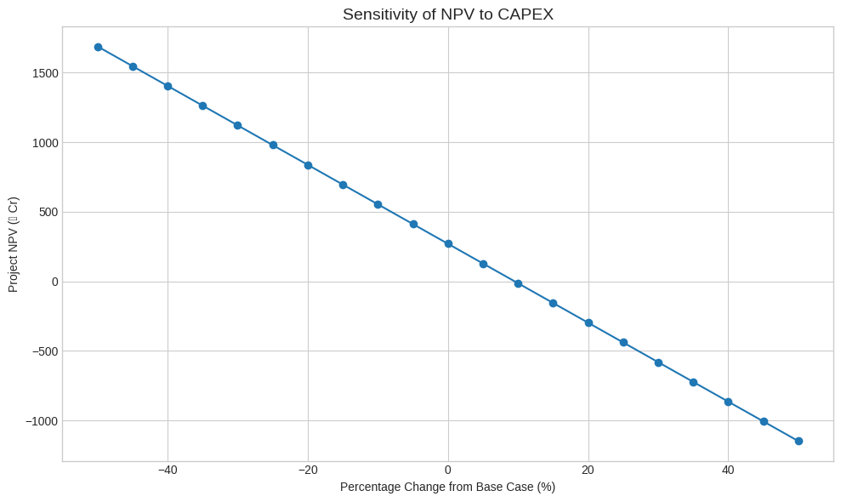

FCFF = Operating CF − CAPEX − ΔNWC
· Calculation: Free Cash Flow to Firm (₹ Cr).
· Description: Cash available to all capital providers; basis for valuation.

WACC = Re × We + Rd × Wd × (1 − Tax)
· Calculation: Weighted average of equity and after-tax debt cost.
· Description: Discount rate for FCFF; key NPV sensitivity lever.
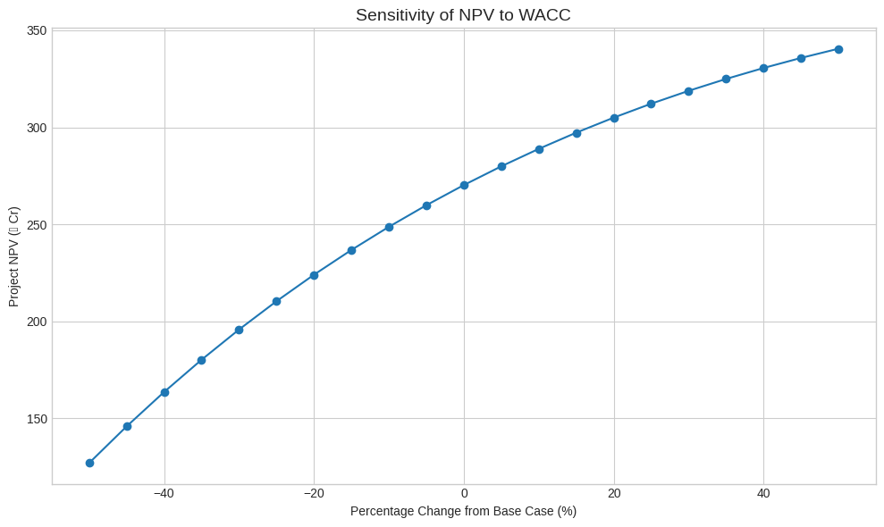

PV of FCFF (₹ Cr)
· Calculation: Present value of each year’s FCFF discounted at WACC.
· Description: Reflects the time value of money.

NPV of FCFF (₹ Cr)
· Calculation: Sum of PV of FCFF − Initial Investment.
· Description: Decision metric; positive NPV indicates value creation.
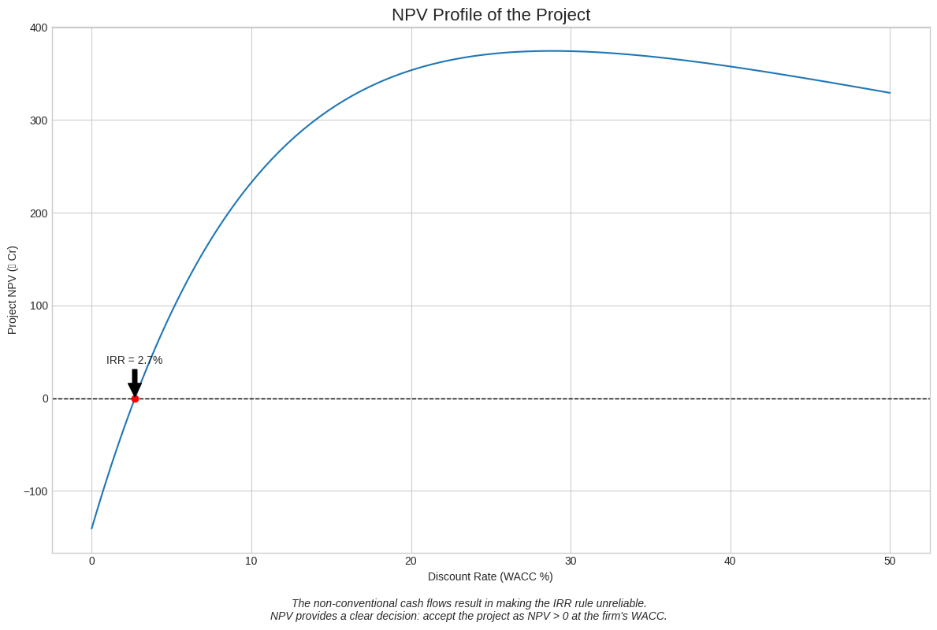
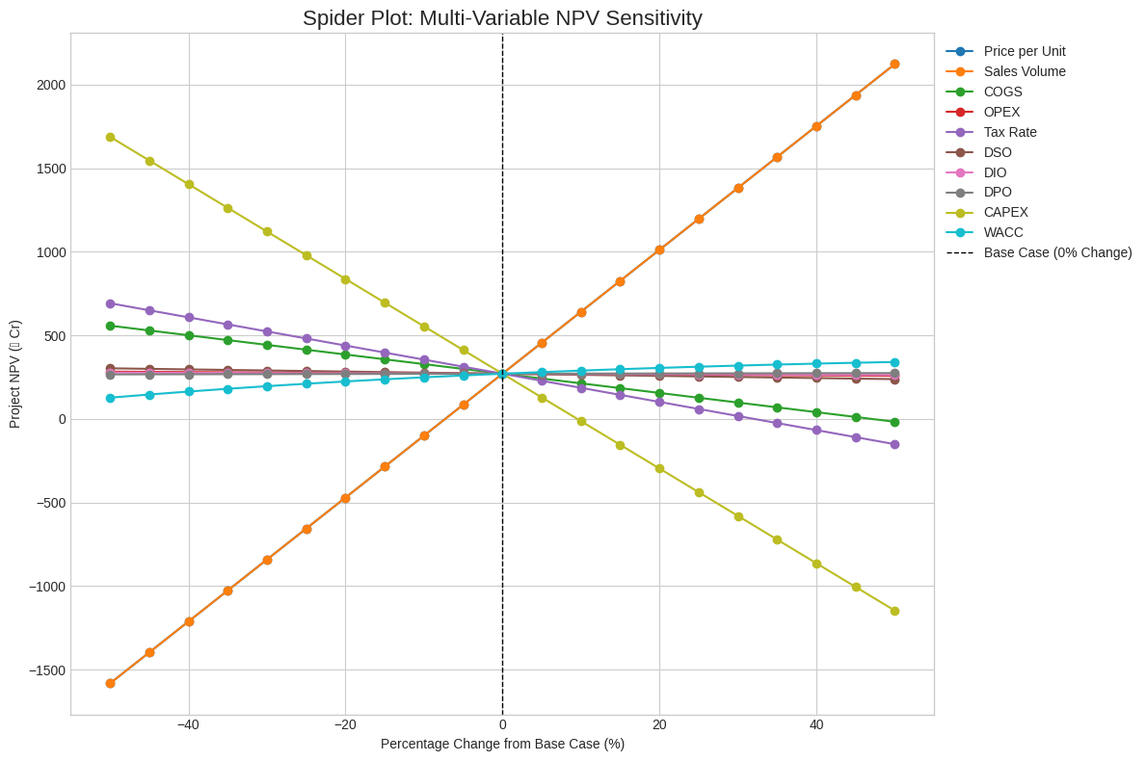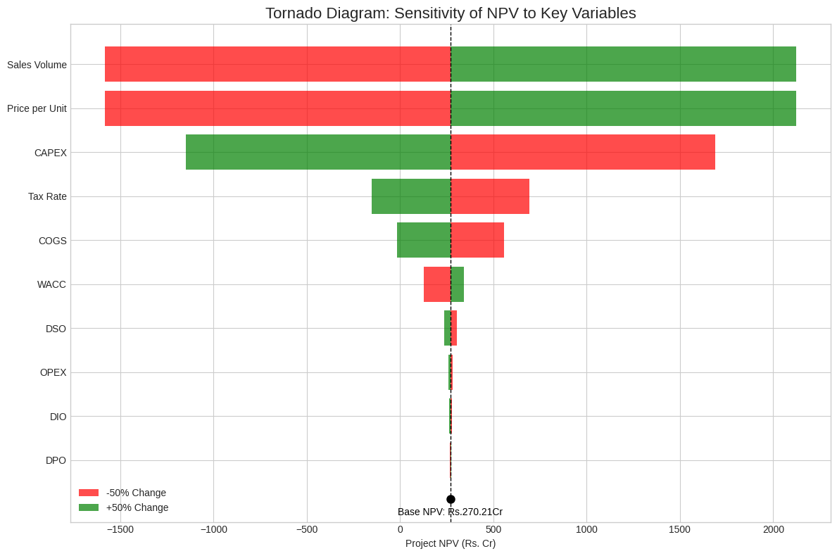

Learning Objectives
· Understand how each operating and financial driver causes the respective changes in FCFF and NPV.
· Use sensitivity analysis to see the impact of each driver on NPV.
· By extension, learn to make an informed choice regarding investments and the impact sensitivity analyses may have on them.

Conclusion
- Sensitivity of NPV (Net Present Value) w.r.t. different parameters in Decreasing order is
Where + signifies that NPV increases as the respective parameter increases, and similarly - signifies that NPV decreases as the respective parameter increases.
- Sensitivity of NPV varies greatly in parameters:- PRICE, QUANTITY, COGS, WACC, CAPEX, TAX.
- NPV is not much sensitive to parameters such as OPEX, DIO, DSO, DPO.

Discussion Prompts
1. Which two variables drive most of the NPV volatility in the base case?
2. What switching values (price decline, cost increase, WACC rise) would erase the project NPV?
3. What trade-offs exist between lower capex today and higher maintenance costs tomorrow?
4. How can sensitivity insights guide board-level investment decisions?

Bibliography
- https://www.researchgate.net/publication/343165155_Sensitivity_Analysis_of_Net_Present_Value_due_to_Optimal_Pit_Limit_in_PT_Ceria_Nugraha_Indotama_Kolaka_Regency_Southeast_Sulawesi_Province
- https://en.wikipedia.org/wiki/Sensitivity_analysis
- https://www.varunbeverages.com/annual-reports/

